**The Chemiluminescence of Molecular Crystals from Organic Peroxides**

Stefan Schramma, Durga Prasada, Patrick Comminsa, Liang Lia, James Westona, Dieter Weissb, Panče Naumova

a New York University Abu Dhabi, P.O. Box 129188, Abu Dhabi, United Arab Emirates  
b Friedrich Schiller University Jena, Institute of Organic and Macromolecular Chemistry, Humboldtstraße 10, 07743 Jena, Germany

The core reaction of all known bioluminescence and most organic chemiluminescence reactions is the thermal decomposition of peroxides.[1] A majority of these compounds are thermally labile, and they can readily decompose in a very exothermic reaction to excited-state light-emitting molecules. Upon relaxation to the ground state, the products emit light with an energy that is proportional to the energy difference between the two states. Due to the intrinsic instability of the peroxo group, the chemiluminescence of organic peroxides has been mainly studied in solution. Only an exiguous amount of chemiluminescence examples in solid state have been reported by incorporating cyclic peroxides into polymers and visualizing their mechanical properties by luminescence imaging.[2] As early as 1926 it was noted that solid endoperoxide of rubrene emits red light when heated [3], a phenomenon which is most likely caused by cleavage of singlet oxygen. The details of the solid-state chemiluminescence have remained unexplored thus far.

This has inspired us to investigate the behavior of crystalline cyclic and open organic peroxides upon heating. Since organic peroxides are known to be highly explosive, our target molecules had to be selected while considering safety risks with handling such compounds in reasonably large quantities. Moreover, good crystallinity was a prerequisite for single crystal x-ray diffraction analysis. Adamantylidene-adamantane dioxetane (**1**) and Lophine-hydroperoxide (**2**) were ultimately selected as representatives of cyclic- and hydro-peroxides that comply with these requirements. Both compounds were synthesized in large quantities (> 1 g) by wavelength-optimized photooxygenation reactions with heterogeneous photocatalysts. This method provides a very easy, safe and efficient way of preparing the peroxides by [2+2] cycloadditions and Schenk-Ene reactions. When crystals of (**1**) or (**2**) were heated above 373 K, they started to emit light. This process can be followed spectroscopically, by using luminescence spectroscopy, and in a spatially resolved mode by applying low-light microscopy techniques [4]. Single crystal and powder diffraction analyses as well as luminescence kinetic studies provided insights into the reaction mechanisms and allowed comparison with the analogous reactions in solution.

 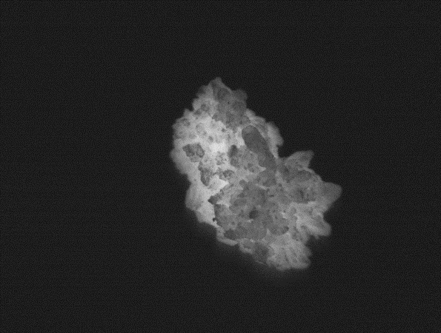

Figure: Adamantylidene-adamantane dioxetane (**1**) and Lophine-hydroperoxide (**2**) as well as a Chemiluminescence Image of a crystalline sample of (**2**) heated to 373K

1. Z. M. Kaskova, A. S. Tsarkova, I. V. Yampolsky, Chem. Soc. Rev. **2016**, *45*, 6048-6077.   
2. a) Chen, Y.; Spiering, A. J. H.; Karthikeyan, S.; Peters, G. W. M.; Meijer, E. W.; Sijbesma, R. P. *Nat. Chem.* **2012**, *4*, 559.   
 b) Chen, Y.; Sijbesma, R. P. *Macromolecules* **2014**, *47*, 3797.   
3. a) Moureu, C.; Dufraisse, C.; Butler, C. I. *Compt. Rend.* **1926**, *183*, 101.   
 b) Moureu, C.; Dufraisse, C.; Dean, P. M. *Compt. Rend.* **1926**, *182*, 1584.   
 c) Adam, W. *Chem. unserer Zeit* **1981**, *15*, 190.   
4. Kim, T. J.; Turkcan, S.; Pratx, G. *Nat. Protocols* **2017**, *12*, 1055.